

Online Shopping Mall project 

Surjyendu Ray,
Suvendu Bhattacharya,
Sandip Shaw,
Souvik Sett

Web Application Final year Project

Online Shopping Mall
PROJECT REPORT

Team name: - SkyNet

Version: - 1.0

Table of Contents
1. Introduction 5
1.1 Purpose 8
1.2 Scope 8
1.3 Definitions, Acronyms and Abbreviations 9
1.4 References 10
1.5 Technologies to be used 10
1.6 Overview 10
2. Overall Description 10
2.1 Product perspective 10
2.2 Product function 11
2.3 User charecteristics 11
2.4 Constraints 12
2.5 Use-Case Model Survey 12
2.6 Architecture diagram 17
2.7 Database design 18
2.8 Assumptions and Dependencies 19
3. Specific Requirements 19
3.1 Use-Case Reports 19
4. Software system attributes 34

5. Action Sequences 36

6. User Interface design 39

7. Web Application Testing 45

8. Acknowledgement 48

9. Bibliography 49



CERTIFICATION

This is to certify that the project entitled “Online Shopping Mall” is a
bona fide record of work done by:

• Surjyendu Ray: -

……………………………………………………………………………………….

• Sandip Shaw: -

……………………………………………………………………………………….

• Suvendu Bhattacharya:-

……………………………………………………………..

• Souvik Sett:-

……………………………………………………………………………………

Under my guidance and supervision, submitted as partial fulfillment of the
requirements for the award of Bachelor of Technology degree in Computer
Science & Engineering by West Bengal University of Technology.

………………………. ……….….………………………………………………………………
Dr. (Mrs.) Ananya Kanjilal
ASSISTANT PROFESSOR (IT DEPARTMENT)
B.P.PODDAR INSTITUTE OF MANAGEMENT
AND TECHNOLOGY
Project Synopsis

Online Shopping Mall

Description of the Project
The Online Shopping Mall (OSM) application enables vendors to set up online shops, customers to browse through the shops, and a system administrator to approve and reject requests for new shops and maintain lists of shop categories.
Also on the agenda is designing an online shopping site to manage the items in the shop and also help customers purchase them online without having to visit the shop physically.
Our online shopping mall will use the internet as the sole method for selling goods to its consumers. The consumer will be in complete control of his/her shopping experience by using the “unique storefront” concept. Shopping will be highly personalized and the mall will provide lower prices than most competitors. This, in brief, is a description of our product which will showcase a complete shopping experience in a small package.
Purpose
- Today the internet and its boom have created a new economic scenario that not only stresses on the classical concept of the “product” but also on the modern concept of “service”. It is this level of service that dictates whether a commercial venture will succeed or not in the market. To provide a high accessibility of service we will design the online shopping website, so that potential customers need not go to a physical shop to buy products or services. They just need to online to complete their purchases. Unlike the prevailing “brick and mortar” shops which have physical existence, we will operate solely from cyberspace.

- Most current systems have a physical foundation that is the root cause to quite a number of problems. By maintaining multiple store fronts, itself being an expensive proposition, store prices are forced to rise. Thus, by using our product, our clients’ competitors are at a disadvantage because their costs are significantly higher than our costs, allowing our clients to sell the same goods at a lower price. As people become more accustomed to using the internet, they view ordering products and services online as a time-saving and cost-saving experience, which is the very essence of our online shopping system.
- This project envisages bridging the gap between the seller, the retailer and the customer. A very high flexibility is being maintained in the design process so that this project can take the following path : -
    - A multiple merchant venue with each merchant having his/her own window which the customer can visit to browse and subsequently buy the products from
- Maintaining the deliverable goods as well as services through single or multiple windows is also on the agenda.

- Target users :
(Tentative list only)
- Mall Administrator: The Mall Administrator is the super user and has complete control over all the activities that can be performed. The application notifies the administrator of all shop creation requests, and the administrator can then approve or reject them. The administrator also manages the list of available product categories. The administrator can also view and delete entries in the guestbook.
- Shop Owner: Any user can submit a shop creation request through the application. When the request is approved by the Mall Administrator, the requester is notified, and from there on is given the role of Shop Owner. The Shop Owner is responsible for setting up the shop and maintaining it. The job involves managing the sub-categories of the items in the shop. Also, the shop owner can add or remove items from his shop. The Shop Owner can view different reports that give details of the sales and orders specific to his shop. The Shop Owner can also decide to close shop and remove it from the mall.
- Mall Customer/Guests: A Mall Customer can browse through the shops and choose products to place in a virtual shopping cart. The shopping cart details can be viewed and items can be removed from the cart. To proceed with the purchase, the customer is prompted to login. Also, the customer can modify personal profile information (such as phone number and shipping address) stored by the application. The customer can also view the status of any previous orders.
- Employees:
- Purchase department under a Purchase manager to overlook purchasing activities if warehousing needs arise.
- Sales department under a Sales manager who will look after the sale of products and services.
- Accounts department under an Accounts manager to look after the accounting activities of the enterprise.

Software Requirements

Introduction

Purpose
The Online Shopping Mall (OSM) web application is intended to provide complete solutions for vendors as well as customers through a single get way using the internet as the sole medium. It will enable vendors to setup online shops, customer to browse through the shop and purchase them online without having to visit the shop physically. The administration module will enable a system administrator to approve and reject requests for new shops and maintain various lists of shop category
This document is meant to delineate the features of OSM, so as to serve as a guide to the developers on one hand and a software validation document for the prospective client on the other.

Scope
- Initial functional requirements will be: -
- Secure registration and profile management facilities for Customers
- Browsing through the e-Mall to see the items that are there in each category of products like Apparel, Kitchen accessories, Bath accessories, Food items etc.
- Adequate searching mechanisms for easy and quick access to particular products and services.
- Creating a Shopping cart so that customers can shop ‘n’ no. of items and checkout finally with the entire shopping carts.
- Regular updates to registered customers of the OSM about new arrivals.
- Uploading ‘Most Purchased’ Items in each category of products in the Shop like Apparel, Kitchen accessories, Bath accessories, Food items etc.
- Strategic data and graphs for Administrators and Shop owners about the items that are popular in each category and age group.
- Maintaining database of regular customers of different needs.
- Shop employees are responsible for internal affairs like processing orders, assure home delivery, getting customer's delivery-time feedback, updating order's status and answering client's queries online.
- Feedback mechanism, so that customers can give feedback for the product or service which they have purchased. Also facility rating of individual products by relevant customers. Also feedback can be given on the performance of particular vendors and the entire mall as well.
- Adequate payment mechanism and gateway for all popular credit cards, cheques and other relevant payment options, as available from time to time.
- For the previous paragraph, depicting the functions of the system, from the perspective of the various users of the system, the following colour codes has been used :
RED for administrator
BLUE for customer of the shopping mall
GREEN for the employees.

Initial non functional requirements will be: -
- Secure access of confidential data (user’s details). SSL can be used.
- 24 X 7 availability
- Better component design to get better performance at peak time
- Advertisement space where it will effectively catch the customer’s attention and as a source of revenue.
- In addition to the above mentioned points, due to the highly evolving nature of the project, the following are planned to be delivered if deemed necessary:
- Warehousing within the very ambits of the project
- More payment gateways.
- Dynamic price model by which prices can be changed based on demand and supply
- Dynamic Storefront: Each customer will have a web page personalized based on his or her recent purchases. This is the equivalent of having a unique storefront for each customer in hopes of drawing in as many return customers as possible.
This list is by no means, a final one. The final list will be dictated by implementation constraints, market forces and most importantly, by end user demands for whom this is being built.

Definitions, Acronyms and Abbreviations
- SLA: Service Level Agreement or SLA is a formal written agreement made between two parties, the service provider & the service recipient. It defines the term of engagement - the fundamental rules that will govern the relationship.
- EJB: Enterprise Java Beans.
- JAVA EE: Java Enterprise Edition 5 is a programming platform— part of the Java Platform-for developing and running distributed multi-tier architecture Java applications, based largely on modular software components running on an application server.
- HTTP: Hypertext Transfer Protocol is a transaction oriented client/server protocol between a web browser & a Web Server.
- HTTPS: Secure Hypertext Transfer Protocol is a HTTP over SSL (secure socket layer).
- TCP/IP: Transmission Control Protocol/Internet Protocol, the suite of communication protocols used to connect hosts on the Internet. TCP/IP uses several protocols, the two main ones being TCP and IP.

References
IEEE SRS Format

Technologies to be used
Programming languages:
- JAVA EE: Java Enterprise Edition is a programming platform— part of the Java Platform-for developing and running distributed multi-tier architecture Java applications, based largely on modular software components running on an application server.
- HTML, XML: Hyper Text Markup Language and Extensible markup Language are the predominant markup languages for web pages. It provides a means to describe the structure of text-based information in a document and to supplement that text with interactive forms, embedded images, and other objects.
- JavaScript: A client side scripting language used to create dynamic web content and user interface.
Tools & Development Environment
- Apache Tomcat 6.0.18 Server: Apache Tomcat is a Servlet container developed by the Apache Software Foundation (ASF). Tomcat implements the Java Servlet and the JavaServer Pages (JSP) specifications from Sun Microsystems, and provides a "pure Java" HTTP web server environment for Java code to run.
- ECLIPSE J2EE: Eclipse is a toolkit which is designed for the creation of complex projects, providing fully dynamic web application utilizing EJB’s. This consist of EJB tools , CMP ,data mapping tools & a universal test client that is designed to aid testing of EJB’s.

Overview
The rest of this SRS is organized as follows: Section 2 gives an overall description of the software. It gives what level of proficiency is expected of the user, some general constraints while making the software and some assumptions and dependencies that are assumed. Section 3 gives specific requirements which the software is expected to deliver. Functional requirements are given by various use cases. Some performance requirements and design constraints are also given.

Overall Description

Product perspective
OSM is aimed towards the vendors who want to reach out to the maximum cross-section of customer and common people who can be potential customer. This project envisages bridging the gap between the seller, the retailer and the customer. OSM should be user-friendly, ‘quick to learn’ and reliable software for the above purpose. OSM is intended to be a stand-alone product and should not depend on the availability of other software. It should run on both UNIX and Windows based platform.

Product functions
- User: Mall Administrator
Functions: The Mall Administrator is the super user and has complete control over all the activities that can be performed. The application notifies the administrator of all shop creation requests, and the administrator can then approve or reject them. The administrator also manages the list of available product categories. The administrator can also view and delete entries in the guestbook.
- User: Shop Owner
Functions: Any user can submit a shop creation request through the application. When the request is approved by the Mall Administrator, the requester is notified, and from there on is given the role of Shop Owner. The Shop Owner is responsible for setting up the shop and maintaining it. The job involves managing the sub-categories of the items in the shop. Also, the shop owner can add or remove items from his shop. The Shop Owner can view different reports that give details of the sales and orders specific to his shop. The Shop Owner can also decide to close shop and remove it from the mall.
- User: Mall Customer/Guests
Functions: A Mall Customer can browse through the shops and choose products to place in a virtual shopping cart. The shopping cart details can be viewed and items can be removed from the cart. To proceed with the purchase, the customer is prompted to login. Also, the customer can modify personal profile information (such as phone number and shipping address) stored by the application. The customer can also view the status of any previous orders, and cancel any order that has not been shipped yet.
- User: Employees
Functions: Purchase department under a Purchase manager to overlook purchasing activities if warehousing needs arise.
Functions: Sales department under a Sales manager who will look after the sale of products and services, the most important activity.
Functions: Accounts department under an Accounts manager to look after the accounting activities of the enterprise

User characteristics
- The user should be familiar with the Shopping Mall related terminology like Shopping cart/Checking out/Transaction etc.
- The user should be familiar with the Internet.

Constraints
- There is no maintainability of back up so availability will get affected.
- Limited to HTTP/HTTPS.
- Real-life credit card validation and Banking system is not implemented.
- No multilingual support

Use-Case Model Survey
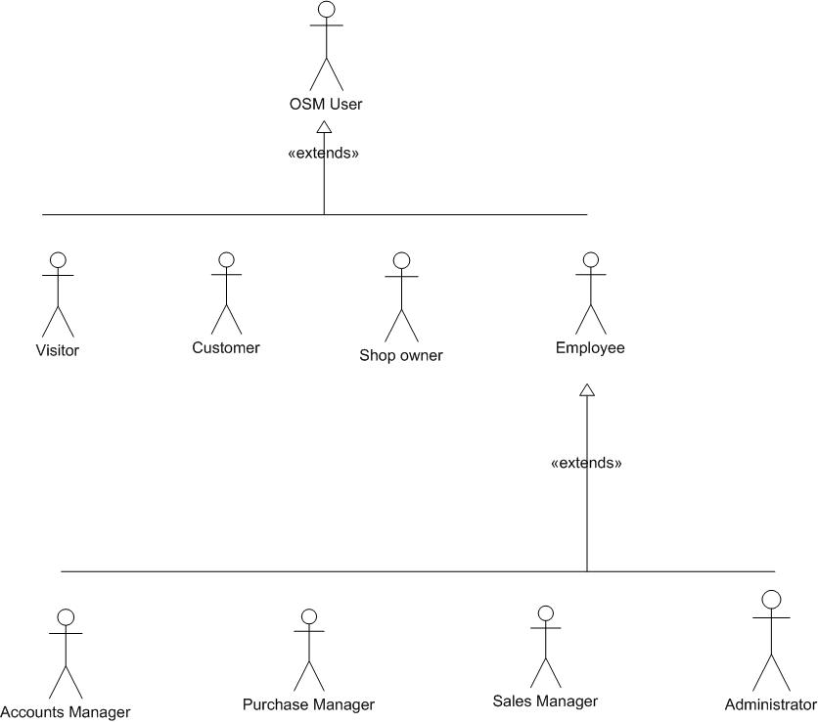
Figure 1: User hierarchy

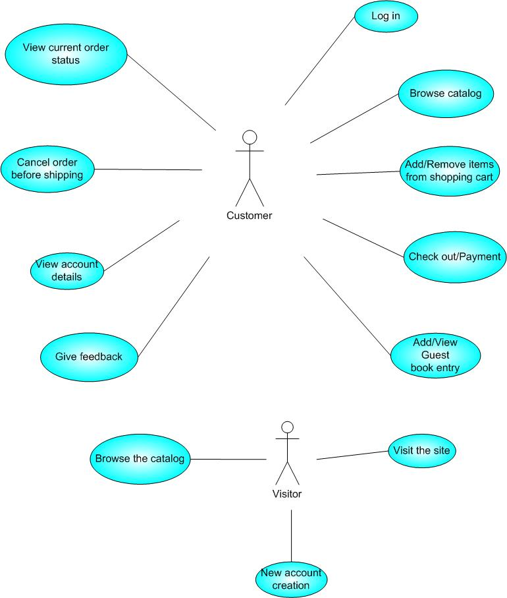
Figure 2: Use case diagram for Customer & Visitor
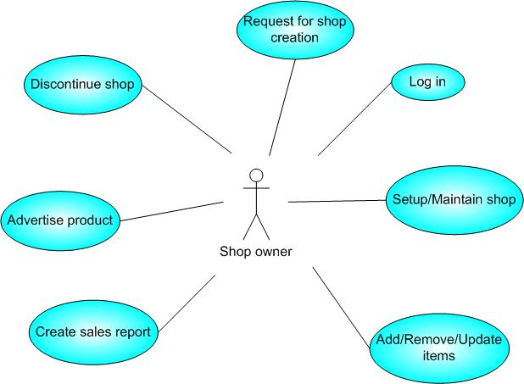
Figure 3: Use case diagram for Shop owner

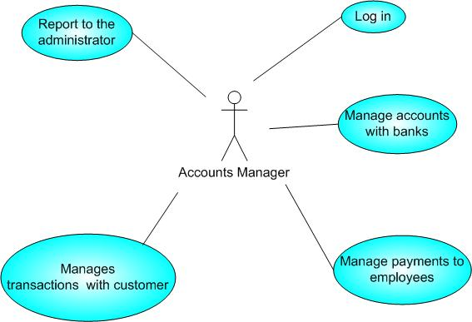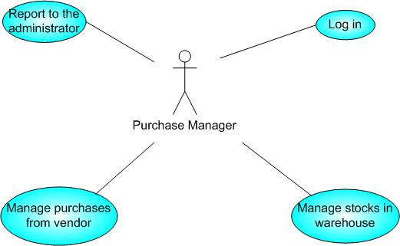

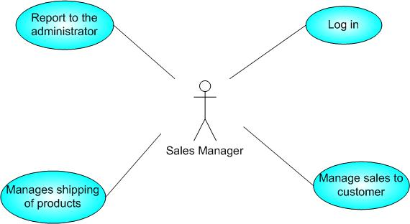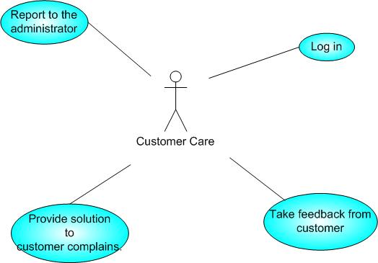

Figure 4: Use case diagram for Employees
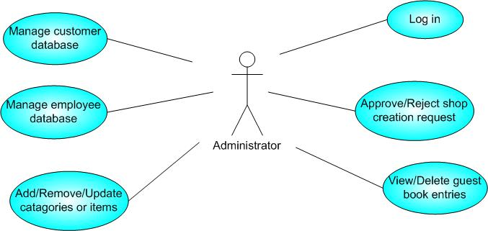
Figure 5: Use case diagram for Administrator

Given below is an overall picture of the system, as depicted in the above use-case diagrams:
Administrator:
- Database Management: Control the database and keep track of all records of customers and employee details.
- Contact and Giving Permission to Vendors: Contact with the vendors and give permission to sell their product under the site after testing the product’s quality.
- View all details: View the details of all employees and control the whole site.
- Advertising the Site: Responsible for making advertisements for the site.
Customers:
- Login: Customers must have a valid login id to enter into the site.
- Registration: New users can sign up by creating new ID.
- View and edit Own Details: Can view/edit his personal details, payment details, and details about services provided.
- Choosing and comparing products: Can view all available products and can compare them and make a choice for purchasing products.
- Purchasing: Can purchase any product through valid credit card.
- Giving Feedback to Customer Care: Can give feedback to the 24X7 Customer Care Service center about their impression for the site and services.
Visitors:
- Visiting the Site: Can only visit the site without registration.
- Register :
Shop Owner:
- Taking Permission from Administrator: Vendors must take permission from the Administrator for selling their products under the site. Administrator will test product’s quality according to its market price to permit vendor for selling purpose.
- Consulting with Administrator: Can consult with the Administrator regarding product’s quality and advertisements.
- Advertising Vendor’s Own Products: Responsible for making advertisements of his products, but the site will not be responsible for any kind of advertisements about products.
Sales Manager:
- View customer details: View the personal details of the customer.
- Managing Sales to Customers: Responsible for properly allocating the selected product according to the customer’s choice and delivering product to the customer.
- View Product Stocks: Keep track of each product item’s stocks for selling purpose.
- Contacting with Administrator: Responsible for informing administrator when any product item’s stock goes under the minimum level.
Purchase Manager:
- Consulting with Administrator: Taking permission from the Administrator for the product to be purchased from vendor.
- Product Stock Management: Responsible for managing stocks of each product items.
Accounts Manager:
- Regulating Payments: Keep track of all the payment transactions made by the customers and update the payment information.
- Consulting with Banks: Responsible for contacting the banks for the validation of the a/c number provided by the customer while purchasing and make the transaction from the given a/c.
- Consulting with Administrator: Consult with the Administrator about the payment details of the customers for the updating of the database.
Customer Care:
- Getting Feedback from the Customers: Responsible for receiving complaints, queries and feedback from the customers.
- Providing Solutions to Customers: Provide feasible solutions to the customers on their complaints and queries.

Architecture diagram

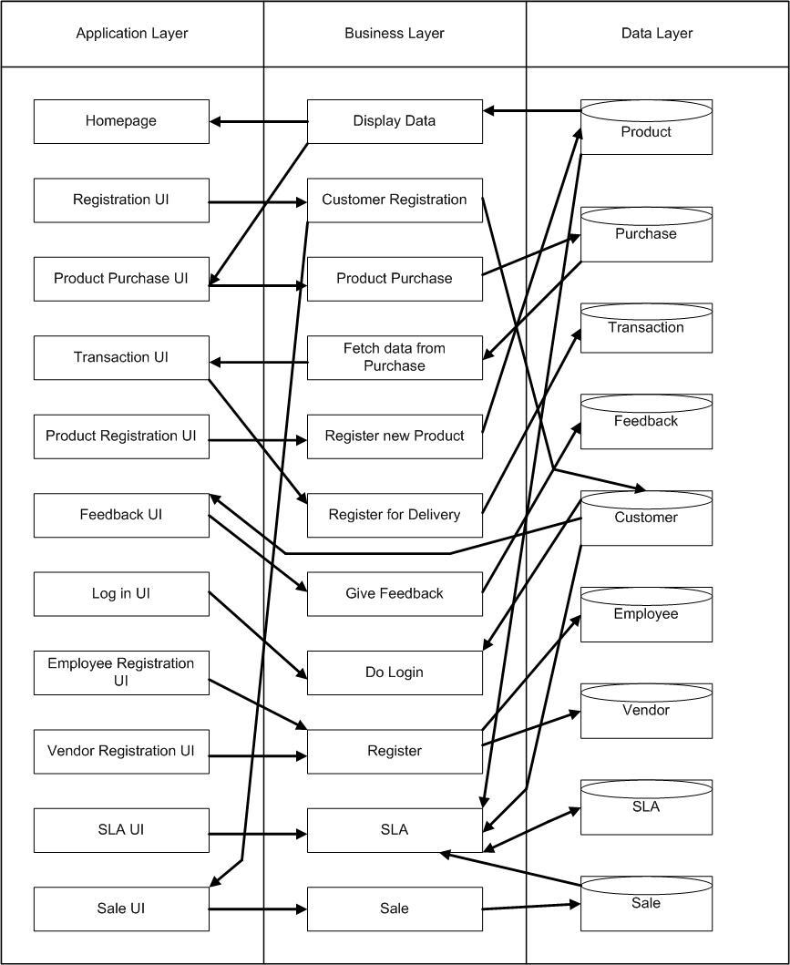

Database design

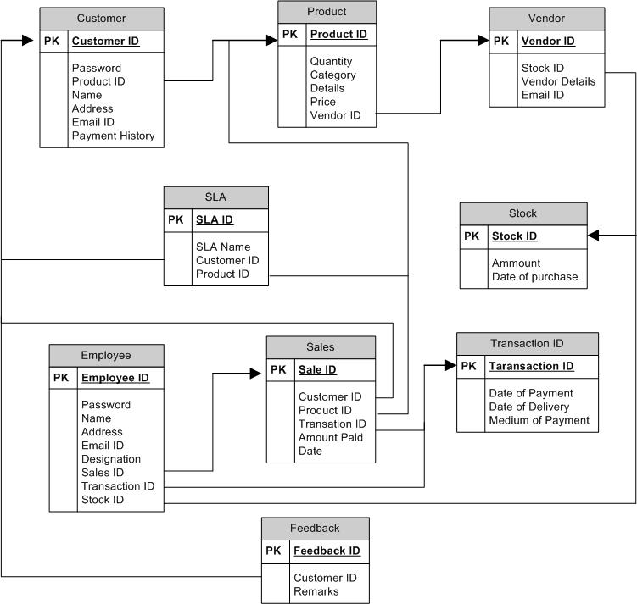

Assumptions and Dependencies
- The details related to the product, customer, payment and service transaction provided manually.
- Administrator is created in the system already.
- Roles and tasks are predefined.

Specific Requirements

Use-Case Reports
- Administrators:
Database Management: Control the database and keep track of all records of customers and employee details.
- Preconditions: Administrator is already logged in.
- Normal flow of events:
1) Normal check of the database by the Administrator.
2) Updating the database (if required).
- Alternate flow of events: None.
- Post Condition: Always updated database.
Contact and Giving Permission to Vendors: Contact with the vendors and give permission to sell their product under the site after testing the product’s quality.
- Preconditions: 1) Administrator is already logged in.
2) Vendor contacts with Administrator.
- Normal flow of events: Negotiation is successful.
- Alternate flow of events: Negotiation is failed.
- Post Condition: possibilities of new product items
Contacting Business Partners: Responsible for contacting with Business Partners who will sponsor the site and help in conducting the business process.
- Preconditions: 1) Administrator is already logged in.
2) Business Partner contacts with Administrator.
- Normal flow of events: Negotiation is successful.
- Alternate flow of events: Negotiation is failed.
- Post Condition: possibilities of new sponsors and raise in investments.
Advertising the Site: Responsible for making advertisements for the site.
- Preconditions: Administrator is already logged in.
- Normal flow of events: 1) Contacting different media.
2) Making advertisements for the site.
- Alternate flow of events: None.
- Post Condition: popularizing the site.
View all details: View the details of all employees and control the whole site.
- Preconditions: Administrator is already logged in.
- Normal flow of events:
1) Administrator views the details of all employees.
2) Controls the whole site.
- Alternate flow of events: None.
- Post Condition: Everything is completely under control.
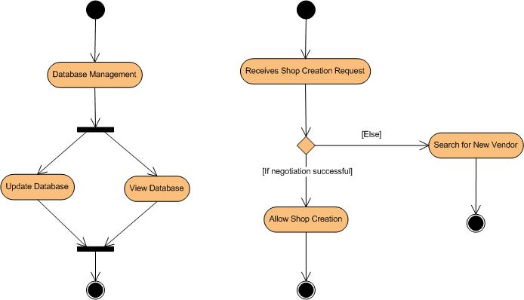
- Customers:
- Preconditions: Customer must have a valid user ID.
- Normal flow of events:
- Log in.
- View and edit Own Details
- Choosing and comparing products
- Purchasing
- Logout
- Alternate flow of events:
1) New customer registration
2) Complaining to Customer Care
- Post Condition: A happy Customer!
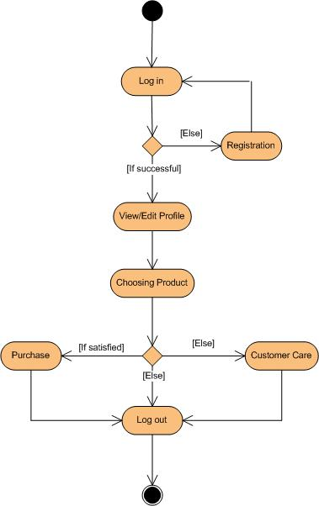

- Visitors:
- Preconditions: Administrator is already logged in.
- Normal flow of events:Visiting the Site
- Alternate flow of events: None.
- Post Condition: Proper separation between customers and window-shoppers.
- Vendor:
- Preconditions: Can consult with the Administrator regarding product’s quality and advertisements.
- Normal flow of events: Can consult with the Administrator regarding product’s quality and advertisements.
- Alternate flow of events: Can leave the project.
- Post Condition: Various attractive items for customers.
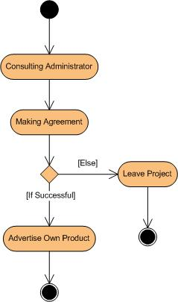
- Sales Manager:
Sales Manager can view customer details and responsible for managing sales to customers, viewing product stocks and contacting with the administrator.
- View Customer Details: View personal details of the customers.
- Managing Sales to Customers: Responsible for properly allocating the selected product according to the customer’s choice and delivering product to the customer.
- View Product Stocks: Keep track of each product item’s stocks for selling purpose.
Contacting with Administrator: Responsible for informing administrator when any product item’s stock goes under the minimum level.

 Name of the use case: View customer details.
Description: View the personal details of the selected customer.
Precondition: Sales manager is already logged in.
Normal flow of events:
 Select customer.
 The details of customer viewed.
Alternate flow of events: None
Post condition: None.

Ask for customer
Customer details
Select customer
MANAGING SALES TO CUSTOMERS:

<<include>> Add purchase details

<<include>>
Update purchase

<<extend>> Manage purchase <<include>>
details View purchase details

<<extend>>
Managing sales <<include>>
Create an SLA
<<include>>

 Manage service level agreement <<include>>
   
View an SLA  

                        Update SLA

 Name of the use case: Add/update and view purchase details.

Description: Store the details of the product sold, customer id, supply details and any changes in product details can be made and view purchase details.

Precondition: Sales Manager is already logged in. The customer is registered and the products are already present.

Normal flow of events:
 Select a customer.
 Select a product.
 Enter/update purchase details.
 Save new data.

Alternate flow of events:
 If the customer is not registered, ask for registration.
 If the product is out of stock, send error message.

Post condition: Sale id is generated.

Select customer
Select product
Ask for registration
Send error message
Registered
Validation
Not registered
Availability
Not available
Available

Sale product

Add/update data

View purchase details

 Name of the use case: Create/update a service level agreement.

Description: Store the details of the services provided to a customer, duration of the services
and details of the terms and conditions

Precondition: Sales manager is already logged in. The product and the services to be provided are already present.
Normal flow of events:
 Select product.
 Select services
 Enter details of the service level agreements.
 Add / update the data.

Alternate flow of events:
 If the product is not present, send error message.

Post condition: SLA is created / updated.

Ask for SLA
Details
Select product
Send error message
Availability
Ask for services
Not available
Available
Select service

Add / update data

 Name of the use case: View service level agreement.

Description: To see the details of the agreement.

Precondition: Sales manager is already logged in. The product and the services to be provided are already present.

Normal flow of events:
 Select product.
 Select date.
 The details of the SLA are shown to the sales manager.

Alternate flow of events:
 If the product is not present, send error message.

Post condition: None.

View SLA
Details
Select product
Send error message
Availability
Ask for services
Not available
Available
Select service

 Name of the use case: View product stock and contact with the administrator.

Description: View stock of a specific product and if stock is low contact with the administrator.

Precondition: Sales manager is already logged in.

Normal flow of events:
 Select product
 View stock.

Alternate flow of events:
 If the product is not present, send error message.
 If stock is low report to administrator.

Post condition: None.

Select product
View stock
Send error message
Report administrator
Available
Availability
Not available
Check
Stock low

- Purchase Manager:
Purchase Manager is responsible for receiving products from vendors , managing product stocks and consulting with the administrator.

- Consulting with Administrator: Taking permission from the Administrator for the product to be purchased from vendor.
- Purchase Order: Responsible for requesting the Vendors to supply required product items of required amount within time.
- Product Stock Management: Responsible for managing stocks of each product items.
 Name of the use case: Consulting with the administrator, requesting the vendors for required products and updating stocks.

Description: Consult with the administrator the products required to be purchased from the vendors, order the products and update stock.

Precondition: Purchase Manager is already logged in.

Normal flow of events:
 Take permission from administrator.
 Place order to vendors.
 Manage stock.

Alternate flow of events: None.
Post condition: None.

Take permission from administrator
Place order to
Vendors
Received
Update stock
Granted
- Accounts Manager:
Accounts Manager is responsible for receiving customer payments, managing customer payment details and consulting with the administrator.

- Regulating Payments: Keep track of all the payment transactions made by the customers and update the payment information.

- Consulting with Banks: Responsible for contacting the banks for the validation of the a/c number provided by the customer while purchasing and make the transaction from the given a/c.

- Consulting with Administrator: Consult with the Administrator about any payment transaction problems.

REGULATING PAYMENTS:

<<include>> Add payment details

<<extend>> Manage payment <<include>>
transaction details Edit payment details

<<extend>>
Regulating payments

        View history

 Name of the use case: Add / edit payment transaction details

Description: All the payment transaction details are entered or edited.

Precondition: Accounts manager has logged in.

Normal flow of events:
  Select the customer.
  Select the product .
 Select transaction id.
 Enter / edit the details of payment.
 Save the payment details.

Alternate flow of event: None.

Post condition: None.

Select customer
Select product
Select
Transaction id
Enter / edit
Payment details
Save
Payment details

 Name of the use case: View history.

Description: View the payment details of the selected customer.

Precondition: Accounts manager is already logged in.

Normal flow of events:
 Select customer.
 The payment details of customer is viewed.

Alternate flow of events: None

Post condition: None.

Ask for customer
Customer payments details
Select customer

 Name of the use case: Consulting with bank and consulting with administrator.

Description: Consulting the bank for the customer payment and in case of any problem consulting with the administrator.

Precondition: Accounts manager is already logged in.

Normal flow of events:
 Select transaction id.
 View transaction details.
 Contact bank.
 Receive payment.
 Manage payment

Alternate flow of events:
 If any problem contact with administrator.

Post condition: None.

Select
Transaction id
Contact bank
Receive payment
View
Transaction
details
Contact
administrator
Success
Problem
Manage payment
- Customer Care:
Responsible for getting feedback from customers and providing solutions to them.

- Getting Feedback from the Customers: Responsible for receiving complaints, queries and feedback from the customers.

- Providing Solutions to Customers: Provide feasible solutions to the customers on their complaints and queries.

 Name of use case : Getting feedback and providing solutions.

Description : To get feedback from customers about products and services provided and giving solutions accordingly.

Normal flow of event :
 Select customer.
 Get feedback.
 Provide solutions.

Alternate flow of events:
 If customer is not registered ask for registration at first.

Post condition: None.

Select customer
Send error message
Check
Get feedback /
Query
Not registered
Registered
Select service
Provide solutions

4. Software System Attributes

Since, there are a number of attributes of software that can serve as requirements; the following items provide a partial list. These are also known as non-functional requirements or quality attributes.

These are characteristics the system must possess, but that might pervade through the design.

4.2.1 Availability

The system should be available at all times, meaning the user can access it using a web browser, only restricted by the down time of the server on which the system runs. In case of a of a hardware failure or database corruption, a replacement page will be shown. Also in case of a hardware failure or database corruption, backups of the database should be retrieved from the server and saved by the administrator. Then the service will be restarted.

4.2.2 Reliability

The reliability of the overall program depends on the reliability of the separate components. The main pillar of reliability of the system is the backup of the database which is continuously maintained and updated to reflect the most recent changes. Also the system will be functioning inside a container (since the implementation is J2EE oriented). Thus the overall stability of the system depends on the stability of container and its underlying operating system.

4.2.3 Security

- Passwords will be saved encrypted in the database in order to ensure the user's privacy.
- The user's IP will be logged.
- Sensitive data will be encrypted before being sent over insecure connections like the internet.
- Certain functions will be assigned to certain modules only.
- Data integrity will be checked for critical variables.

4.2.4 Maintainability

A commercial database is used for maintaining the database and the application server takes care of the site. In case of a failure, a re-initialization of the program will be done. Also the software design is being done with modularity in mind so that maintainability can be done efficiently.

4.2.5 Portability

The application is J2EE based and should be compatible with all other systems which have a native Java implementation. The end-user part is fully portable and any system using any web browser should be able to use the features of the application, including any hardware platform that is available or will be available in the future.

5. ACTION SEQUENCES

This section describes in detail the sequence of steps that are needed to be done by the users of the system to utilize the functionalities being provided by this web application. Grouping the actions by users, we start from the following user of the system:

- The customer:

- The customer is the main user of the sopping mall website and is the main reason why this web application exists in the first place. The customer can browse through the shops and choose products to place in a virtual shopping cart. The shopping cart details can be viewed and items can be removed from the cart. To proceed with the purchase, the customer is prompted to login. Also, the customer can modify personal profile information (such as phone number and shipping address) stored by the application. The customer can also view the status of any previous orders, and cancel any order that has not been shipped yet.

Since the customer is the main user of the system, we will follow the customer as he or she goes about with the various activities in the shopping mall. This way we will have explored all the ways this shopping mall functions as well as obtained an “algorithm” of the steps of functioning of the entire shopping mall application.

The algorithm is:

Step 1: A potential customer X visits the website of OSM.

Step 2: X either knows the product he or she is searching for or is unaware of his expectations from the shopping mall.

Step 3a: If X knows the product he is searching for he enters the name of the brand of that product in the search box on the home page itself. He is then whisked right to the separate page for that brand, where he can choose the product according to his liking.

Step 3b: If X wants to browse the products before deciding what to buy, then he can choose the categories of the products in the home page itself. From there he will be taken to the product categories page from where he can choose the brand that appeals to him.

Step 4: After selecting the brand of the product, X can click on a particular product which will take him to the product page for that particular product. This page contains all the detailed information about the product.

Step 5: Now that the product has been selected, X might want to actually buy the product. He will then have to log in to the website to actually affect the buying process.

Step 5a: If X is a new user, he will have to first register in the website’s new user registration page. Then he will be able to login to the website and complete he transaction.
Step 5b: X may also wish to view his account detail in the account details page. There he can check and change his contact information. He can also view his shopping cart including any incomplete shopping carts which have not matured to the buying status.

Step 6: When X selects to buy the product he may follow two paths.

Step 6a: X may add one item to his shopping cart and then keep on browsing the store for more good things. When he has filled his cart to the brim, he can rush to checkout the shopping cart on the shopping cart page.

Step 6b: Or X may decide to buy just one product and rush to checkout the product. He can then in the checkout page put in his credit card information and submit the information. That will complete the transaction process.

Step 6c: Or after browsing for some products, X can come back to his incomplete cart and complete the payout process.

Step 7: X will have to provide his credit card details and then proceed to check out. Then he will be given a confirmation that his credit card has been validated and that he will receive the product within a stipulated time frame.

The flowchart for the aforementioned steps:

Know product
View category
Select category
Select product
Search
Log in
Registration
View/edit profile
Select product
Buy directly
Add to cart
Checkout
Input payment details
Get confirmation
Else
If successful
To shop more and add more products

6. USER INTERFACE DESIGN

Every user interface- whether it is designed for a WebApp, or a traditional software application- should exhibit the following characteristics:

- Easy to use.
- Easy to learn.
- Easy to navigate.
- Intuitive.
- Consistent.
- Efficient.
- Error-free.
- Functional.
It should provide the end-user with a satisfying and rewarding experience. Our OSM web application follows all these principle of effective user interface design. Like an effective interface, OSM is visually apparent and forgiving, instilling in its users a sense of control. Users quickly see the breadth of their options, grasp how to achieve their goals, and do their work. It does not concern the user with the inner workings of the system and the users have the full option to undo activities at any time eg. to remove item from the shopping cart.
Like effective applications and services, OSM performs a maximum of work, while requiring a minimum of information from the users.

Screenshots of the OSM website:

- The first screenshot is that of the home page or the index page which comes first to the browser when someone will be visiting the website of OSM.

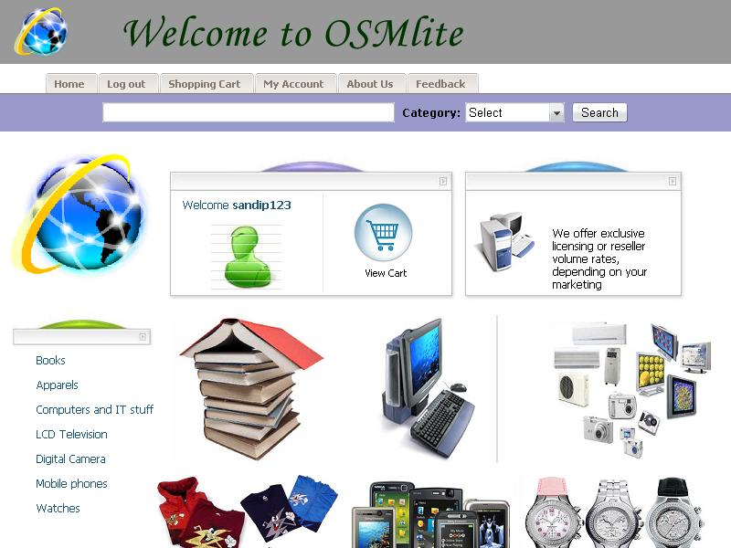

- The second screen shot is that of the login page, which will pop up when someone will try to buy a product from the shopping mall.

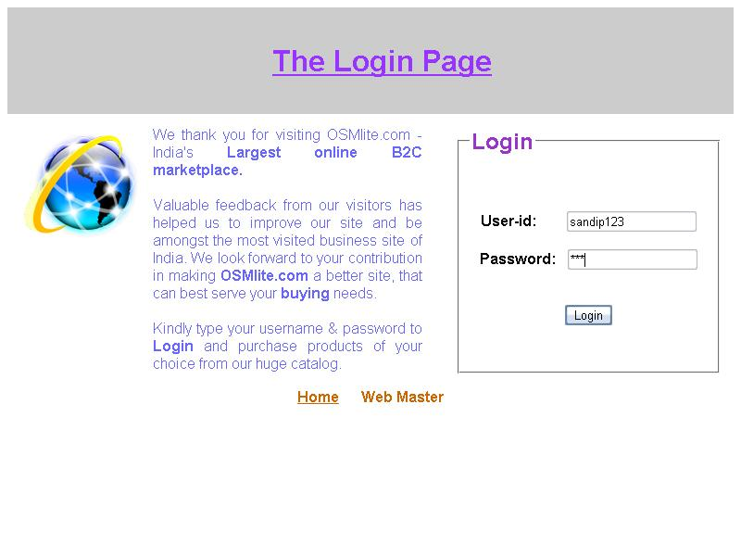

- The third screen shot is that of a category page which is showing all the products that are available in a category of products (here computers is the category).

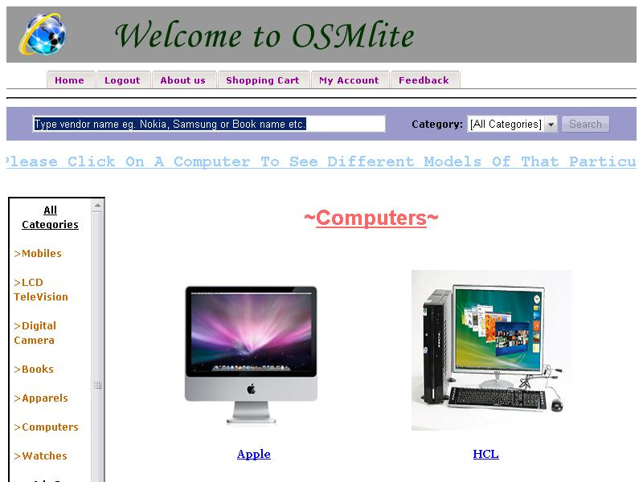

- The fourth screen shot is that of the shopping cart where customers of the shopping mall can keep the goods which they want to buy. A loaded shopping cart is being shown here.

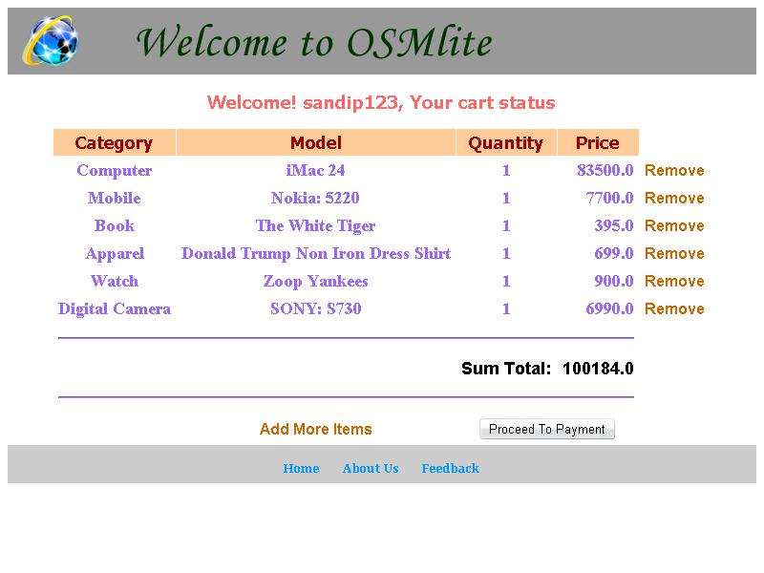

- The fifth screen shot is that of the buy page where the customer will have to provide his/her credit card details to complete the shopping process.

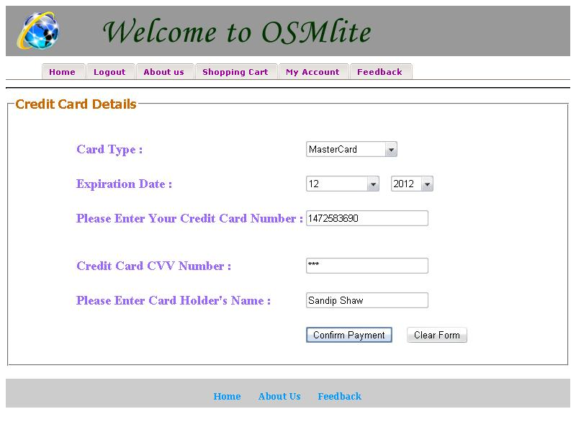

7. WEB APPLICATION TESTING

Web application (WebApp) testing is a collection of related activities with a single goal: to uncover errors in WebApp content, function, usability, navigability, performance, capacity, and security. To accomplish this, a testing strategy that encompasses both reviews and executable testing is applied throughout the Web engineering process. If end users encounter errors that shake their faith in the WebApp, they will go elsewhere for the content and function they need, and the WebApp will fail. For this reason as many errors as possible must be eliminated before the WebApp goes online.
The WebApp testing process begins by focusing on user-visible aspects of the WebApp and proceeds to tests that exercise technology and infrastructure. In some instances a WebApp test plan is produced. In every instance, a suite of test cases is developed for every testing step and an archive of test results is maintained for future use.

Quality is incorporated into a web application as a consequence of good design. In our project as well, the following quality dimensions have always been the cap stones in the development process:

- Content is evaluated at both the syntactic and semantic level.
- Function is tested to uncover errors that indicate lack of conformance to customer requirements.
- Structure is assessed to ensure that it properly delivers content and function, that it is extensible, and that it can be supported as new content or functionality is added.
- Usability is tested to ensure that each category of user is supported by the interface.
- Navigability is tested to ensure that all navigational syntax and semantics are exercised to uncover any navigational errors.
- Performance is tested under a variety of operating conditions to ensure that the system is responsive to user interaction and operates without unacceptable operational degradation in contingency situations.
- Compatibility is tested by executing the web application in a variety of different hosts on both the client and server sides.
- Interoperability is tested to ensure that the WebApp properly interfaces with other applications and/or databases.
- Security is tested by assessing potential vulnerabilities and attempting to exploit each.

The color codes that have been used here signify the extent of testing that the OSM product has undergone in its first version.
Green signifies that the components have been tested according to the described pathway.
Red signifies that the components have not been tested according to the described pathway due to lack of infrastructure but will be tested in the next version.
Violet signifies that the components have been tested partially according to the described pathway and new features will be added in the next version.

Some test cases which we have utilized to test our product:

- Test premise: To test whether users can log into their respective accounts and view their contact and shopping cart details, whether employees and the administrators can login to their respective accounts.
Test type: Security.
Test structure:
  - We created several dummy accounts for all the types of users like customers, employees and administrators. We then logged into the respective accounts using the corresponding user names and passwords.
Test result: Success.
  - We then mixed up the user names and the passwords and tried to log into the respective accounts. But we could not since each user has a unique user name and password. Thus all the user accounts are safe from unauthorized intrusion. Also the browser “back” button cannot be misused to gain access to the respective account after a user has successfully logged out
Test result: Success.

- Test premise: To search for products and browse the catalogue of products.
Test type: Navigability, Content.
Test structure:
  - We tested the navigability of the website by browsing the entire catalogue of products. We went to the different categories and looked for product inside the category. We did a random sampling of product paths from various points in the website to sniff out any dead links.
Test result: Success.
  - We also searched for a particular product from the home page and the search page to find out whether our searches are producing relevant results. We also tested the content of every product page to find out whether the content provided is the same as that provided by the manufacturer of the product.
Test result: Success.

- Test premise: To add/remove items from the shopping cart and update it as well.
Test type: Usability, Structure.
Test structure:
  - We tested the usability of the shopping cart mechanism by repeatedly adding and subsequently removing items from the shopping cart. We also checked the corresponding money value of the shopping cart to find out whether it truly reflects the present contents of the shopping cart.
Test result: Success.
  - We also tested the update feature of the shopping cart by first loading the shopping cart with products and then navigating away to the home page to browse and add more products to the shopping cart. We came back to the shopping cart to check:
      - Whether the previous items in the cart are still there in the cart.
      - Whether the newly added items have been added properly and in the right quantity which we selected for each product.
      - And, whether the total money value of the cart equals the total of the costs of all the goods in the cart.
Test result: Success.

- Test premise: To test whether the exact amount of money value of products which the customer has bought has been billed to him.
Test type: Function.
Test structure:
  - We tested whether the total value of a shopping cart of a particular customer has been billed to the corresponding customer and not to any other customer. We also checked the database entries to find out whether every customer account has the right amount of money billed to him or her and whether that amount of money signifies the current value of the shopping cart.
Test result: Success.

8. ACKNOWLEDGEMENT

A study or a project of this volume can never be the outcome of a single person or
just a mere group of dedicated students. Rather it is the culmination of the leadership and valued guidance of a leading figure who inspires and whips up a frenzy of activity, yet keeping the entire team focused on the final goal. So we are happy to present a vote of thanks to them for their sincere advice and co-operation that they have lent us unconditionally.

We are indebted to Drs. Mrs. Ananya Kanjilal and Sabnam Sengupta (Assistant Professor (IT Department), B. P. Poddar Institute of Management & Technology) for being the epitome of guidance during the entire project.
They have encouraged us whenever we have been in exigency situations and have kept us focused on the work at hand no matter how high a mountain we faced. Without their painstaking and awesome efforts in keeping everything pristine and perfect the project would not have reached its present immaculate state.
We must not forget the role of West Bengal University of Technology where the authorities decided upon incorporating such projects in our course which helped us to understand and learn a lot through practical experiences.
We are also thankful to other faculty members for their encouragement. Without their help this project would not have seen the light of day.

• Surjyendu Ray ( UNIVERSITY ROLL NO-11502052008)
• Sandip Shaw ( UNIVERSITY ROLL NO-11502052002)
• Suvendu Bhattacharya (UNIVERSITY ROLL NO-11502051016)
• Souvik Sett (UNIVERSITY ROLL NO-11502051012)

DEPARTMENT- INFORMATION TECHNOLOGY(IT)
SEMESTER - 8TH
COLLEGE- B.P.PODDAR INSTITUTE OF MANAGEMENT AND TECHNOLOGY

9. BIBLIOGRAPHY

To bring the project to a fruitful completion we have consulted several websites and books. We are giving a list of the important books and websites. These were the initial points of our research for this project.

- Software Engineering by Roger S. Pressman
- Internet an World Wide Web How to Program by Deitel and Deitel
- Java How to Program by Deitel and Deitel
- http://www.tgmc.in/project_scenario_view.php?page=1&id=5
- Professional Java Server Programming (APress).

And for everything else, we had http://www.ibm.com/developerworks/java/library/

